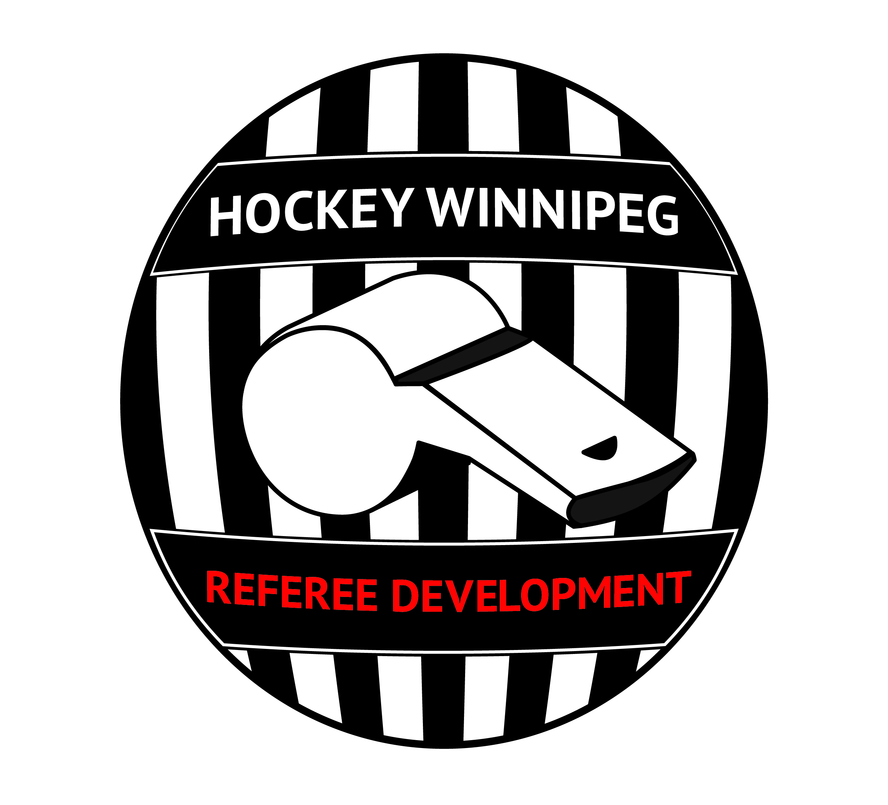
HWRD Introduction to Game Management Course
2) Managing yourself
a) During a hockey game, what events or situations increase your stress or your adrenaline?
b) What strategies do you use to keep yourself engaged in a boring game?
c) During a hockey game, what strategies do you use to decrease your stress levels?

3) Mindfulness
a) How might you apply this type of tool while you referee a hockey game? What situations may you apply this skills?
b) What are the barriers to using this type of skill during a game?

1) An example of a bad situation
Think of one situation from a game you have officiated (or seen) that got out of hand? How did you (or the ref) handle the situation? How did it get out of hand? What would you have done differently to prevent that situation? If there was nothing you could do, what factors led to the event?

___________________________________________________________________________________
4) To Read: In-game stress reduction
(this resources is found on wpgrefs.com)
Refereeing is a stressful job and stress levels rise under various circumstances such as:
- Making a call that you wish you had not made or making a good call at a call at a key time
- Having the fans yell; having the coaches yell
- Being mentored
This article aims to discuss what we can do about stress while we are in the middle of a game. Stress is an important topic for referees because, a side from decreasing our job satisfaction, it also increases the risk of making more errors. Here are two techniques that can be done in less than 5 seconds and may help you decrease stress:

Progressive Muscle Relaxation (PMR)
PMR has two steps and can be applied to any muscle group of ones’ body.
- Tense muscles
  - Select a group of muscles (i.e. one of your arms/hand)
  - Take a deep breath, tense/flex that muscle group as hard as you can
  - Count to 5 (or the length of one part of the line change procedure)
- Relax the muscles
  - After 5 seconds let your breath out
  - Let the muscles relax.
Mindful Based Stress Reduction (MBSR) 5-second breath-awareness
Stress is often associated with worrying about the future or regretting the past. Therefore, a second method or stress reduction is being in the present and MBSR, in its simplest form, is a breathing-focus technique. Here are three steps to a 5 second present-focus exercise:
- Focus on your breath, feel your chest expand and contract, feel the air move down into your lungs and then out again, let your thoughts drift to the back of your mind and just be with your breath.
- Open your awareness to your senses (seeing, tasting, hearing, touching, smelling). What is the first thing that you are aware off? Do not analyze whatever you are sensing, do not think about it, just accept and appreciate it
- Bring yourself back to the present moment with a clear mind ready to referee.

5) Identify hotspots
For each of the following 1) identify potential hot spots for the officials to establish presence by circling the area on the ice and 2) by labeling the position the officials should take on the ice in the two-official system.

- At the end of the game, there are opposing players in the penalty box and play ends in visitor’s zone.
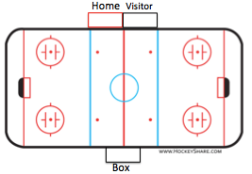

- Coincidental penalties come to an end but cannot leave the box until the next stoppage (that happens to occur in Visitor’s end)

- After the ice is flooded, the teams are coming on the ice.
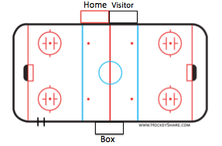
The teams come in the same gate The teams come in different gates
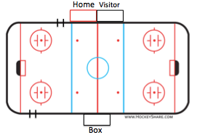

- After a goal is scored.
By the visiting team in period 1 or 3 By the home team in period 2
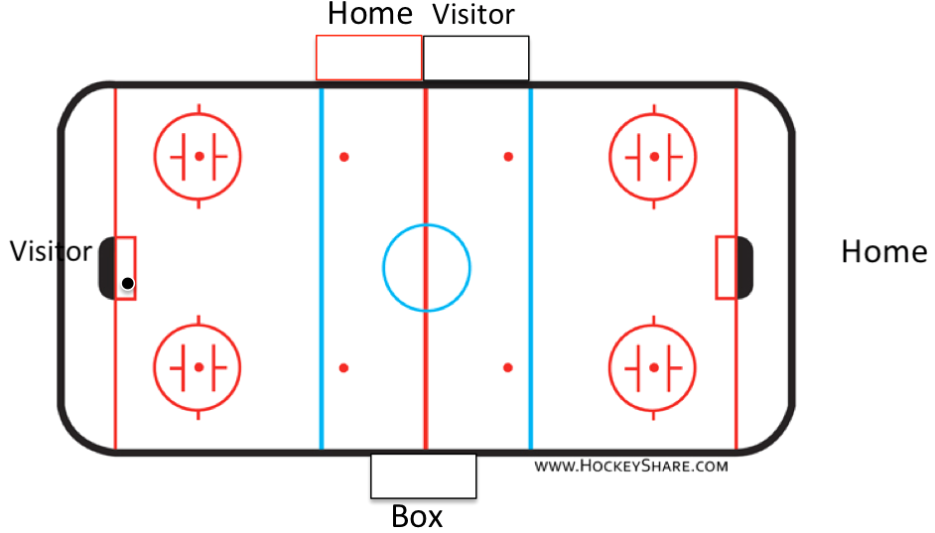
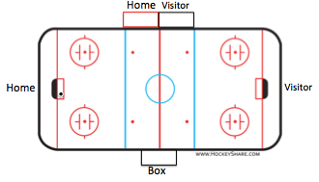

- Second period, delayed penalty against home, the visitor goalie is pulled then returns to the net at the next stoppage.

- There is at least one penalty called against both teams.

- Handshake line is taking place.

6) To read: Talking to a coach
(this resource is found on wpgrefs.com)
Talking to coaches/captains is a part of the game. Whether you talk to a coach or not depends on your
style, the demands of the game, and the level of hockey. Here are some guidelines for you to consider:
- State your opinion, listen to the coach/captain, then leave. Do not argue or debate or discuss.
- Never talk to a coach/captain at the end of the period (especially if there is a flood). This sets you up for a long conversation that may be related to his or her being upset.
- If you must talk to a coach/captain between periods, do so right before the start of the next period (if there is a flood). Make sure you have an excuse to leave (i.e. to drop the puck).
- If a coach/captain is yelling at you, do not talk to him. Penalize, ignore, or talk to the captain/another captain. To the coach, make a circle around the position of an "A" or "C" on your chest and say "CAPTAIN, PLEASE".
- If you penalize a coach/captain, do not go talk to them. The privilege was lost with the penalty.
- Talking to people when they yell at you only encourages them to yell at you more.
- Minimize talking to coaches during the game; talk to the captains to maintain flow of the game.
- When talking to a coach; Ask her to step off the bench to equalize the power between you.
- When to talk depends on the circumstance; many officials only talk to the coach for major penalties. For all else, talk to the captain.
- Whether you talk to a coach or not is up to you. Some referees never speak to coaches (they prefer captains), some always talk to coaches, and sometimes (i.e. little kid hockey) it is a necessity.
- A lot of the time, you need to find a balance between talking or not talking; understand what the situation requires and adapt appropriately.
When talking to a coach/captain, you can phrase a statement to decrease the odds of a long conversation. Remember, the coach or captain may be right but you need to stick to your original call.

For example, consider the following statements
- "Coach he stuck his leg out and made contact ankle to ankle not knee to knee so it is a two minute minor for tripping..."
- "From my angle, Captain, I saw his leg come out then contact was made ankle to ankle so I felt a tripping penalty was more appropriate."
The first statement will get you stuck because you do not leave any “grey-area” as you have effectively made a black-and-white statement. The second statement leaves room for differing opinions for two reasons:
- "From my angle..." gives credit to the nature of refereeing hockey; the referee's perspective effects most calls on the ice. Nothing is black-and-white.
- "I saw..." and "I felt..." both are "I" statements that allow you to take ownership of the call. Again, without saying outwardly, the "I" statement says that you have one angle or perspective and the coach has another.
After you have made a statement with "From my angle..." and an "I" statement the coach may still want to talk (or may say "thank you"). In the event that she wants to talk, your response may be "I am sorry we saw this play from two different angles. However, we need to drop the puck so we can finish the game in the ice-time. Thanks." At this point, even if the coach or captain wants to talk more, the conversation needs to end. The game needs to keep going.

If the coach does not stop wanting to talk or argues, then consider four communication pieces that may effect the message:
- Volume of voice-were you yelling? Did you sound mad? If you had to yell due to a loud arena, did you tell the coach you were yelling due to the arena not due to the conversation?
- Tone of voice-were you assertive with a calm voice (Good) or lecturing (Bad)?
- Pace of voice-did you speak too fast so the coach could not understand or too slow that the coach lost patience?
- What you said-did you use "from my angle" or an "I" statement? Did you focus on the problem (different angles, getting the game going again) or the person (telling the coach off)?
__________________________________________________________________________________
7) Game Management & Impact Penalties
(This resource is found on wpgrefs.com)

Introduction
“Feel for the game” or “game management” is one of the most important skills an official can bring to the ice. It is also one of the most difficult to evaluate and instruct.

The rule book tells us what actions are punishable. The rule book does not tell us exactly when to apply those rules to effectively manage the game. Deciding when to call a penalty, and assessing the impact it will have on a game, are the keys to effective game management.

Here is a hard truth about refereeing hockey: we cannot call every penalty. Hockey is a contact sport, even at those levels where body checking is not allowed. It is fast, fierce and often chaotic. Assessing every penalty that occurs in a hockey game – without regard to its seriousness and impact on the game – would ruin the experience for players, coaches and fans.

But how do we determine the penalties that must be called, and those that are so insignificant that they should not be used to interrupt the flow of the game?

The simple answer is that officials must become good game managers. They must make calls that promote safety and fairness in all aspects of the game. They must read complex situations quickly and confidently, and establish a clearly defined standard for what is allowable and what is over the line.

The Principles of Game Management
Many officials believe that a thorough knowledge of the rules is the most important attribute. Knowing the rules is very important. However, we must not overlook “feel for the game.”

The foundation of “feel for the game” is built on two equally important principles: games must be fair; and they must be safe. We ensure fairness and safety by focusing on the timing, type and frequency of penalties.

Let’s look at some key questions that many officials ask as they attempt to grasp the principles of game management.

When does effective game management begin?
Officials must apply the principles of game management early in the game to establish clear standards for what infractions are unacceptable and which minor infractions will be permitted to keep the game flowing.

Establishing these standards early makes the game safe and fair for everyone. Officials that wait too long to call penalties may find that they lose control of the game. Once a game is out of hand, it is too late to start trying to create a standard of safety and fairness.

How do I recognize an ‘IMPACT Penalty?’
Penalties that threaten the safety and fairness of the game are called “Impact Penalties.” Of course, identifying Impact Penalties is not as easy as it may sound. As you read this section, remember that all the penalties you call should be impact penalties. If a penalty does not qualify as an impact call then do no raise your arm.

Ultimately, there are two questions that define an impact penalty. If you can answer “yes” to both these questions then you definitely have an impact penalty. If you answer “no” to both these questions then you should not be calling anything as you do not have an impact penalty. If you have one “no” and one “yes” to the then you will need to decide if this penalty sends the message that you want to send to the arena. The two questions are:
  - Does the penalty set a clear standard for what is and is not allowed in this game?
  - Can the “Guilty” player change something next time to avoid the same penalty?

Remember, teams will adopt their style to the penalty standard of the referee. All penalties communicate something to the arena. What are you trying to communicate with this penalty call? Think of impact penalties not as a black-and-white rule in a book, but as a communication tool.

The key to good game management: self-evaluation
During a game, referees should always reflect on how players responded to a particular penalty. Did it make the game fairer and safer? Was that an impact penalty? Is that a penalty I want to communicate consistently to the arena? Did the penalty that I called communicate what I wanted it to?

Calling the right impact penalties will help the arena trust you and self-reflection will help the referee adjust her impact penalty selection to avoid calling too many (the arena gets frustrated) or too few penalties (the arena will struggle to understand the standard).

Refereeing is like holding a bird…
Given that the referee is trying to call the right impact penalties rather than too few or too many…think of a hockey game being like holding a bird. If you squeeze a bird too tightly, you can kill it. Hold on to the bird too loosely and it will get away. The same holds true for managing a hockey game.

You need to maintain a firm enough grip on the game to ensure that it is safe and fair. However, you do not want to squeeze the game so tightly that the game grinds to a halt.

The key is balance; holding the game so it is in control, but not squeezing it to death.
___________________________________________________________________________________

Situation  For each video, answer the following questions to better explore impact penalties. | What is the impact penalty or non-call for this situation? | What are you communicating to the arena with this impact penalty or non-call? | What does the player/coach learn from the call to avoid a potential penalty in the future? | If you called it the opposite way what would you communicate to the arena?
1
2a (the play on the attacker)

2b (the bump with the goalie)
3
4
5
6
7
8
9
10
11
12
13
14
15

According to medical and psychological research, these two techniques have been shown to decrease stress and increase performance of students and employees as well as increase survival rates of patients with various illnesses. In general, people who take part in Mindful Exercises report lower stress than a control group of people who do not and, in another study, an MBSR group of seniors experienced less flu symptoms than a group of seniors who did not participant in the MBSR group.

