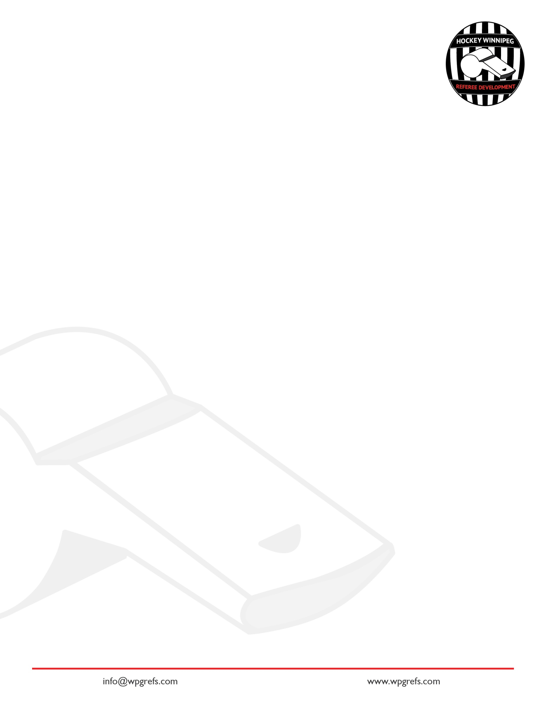
Hockey Winnipeg Referee Development Introduction to Lining Course

Positioning
How is positioning in the two-official system same/different to positioning in the three-official system? ________________________________________________________________________________________________________________________________________________________________________________________________________________________
1

What two places on the ice does a linesperson have a specific system for positioning?
2

________________________________________________________________________________________________________________________________________________________________________________________________________________________

Working the line Activity
3

- Put this booklet on the floor and pretend it is the blue line. The attacking zone is on that side of the blue line
- Explain and show where your feet should be relative to the blue line if the puck is in the attacking zone. Why?
__________________________________________________________________________________________________________________________________________
- Explain and show where your feet should be relative to the blue line if the puck is in the neutral zone. Why?
__________________________________________________________________________________________________________________________________________
4a

As you watch the play from the blue line, where should your feet be pointed?
A) at the puck.
b) down the blue line.
c) back to the other endzone.

Fill in the Blanks. “When working the blue line imagine a ____________ attached between your belly-button and the ____________ which keeps you square to the play; and makes it easier to get out of the way.”
4b

Where should the linesperson who does not own-the-line be standing while watching the play in the attacking zone?
5a

- at the red line
- at the far blue line
- at your partner’s blue line
- within 6 feet of your partner’s blue line

When deciding to switch lines with your partner, who decides to switch lines; the official who owns-the-line or the one that does not own-the-line? _____________________________________________
5b

If the official who owns-the-line has play in her feet, how can she communicate that she needs to switch lines?
5c

________________________________________________________________________________________________________________________________________________

What is the responsibility of the linesperson who does not own-the-line when his partner is forced to leave the line?
5d

________________________________________________________________________________________________________________________________________________

As the linesperson who owns the blue line, what cue(s) are you looking for to decide to follow the play up the ice when it leaves your zone?
6a

________________________________________________________________________________________________________________________________________________

As the linesperson who does not own the current blue line, what cues are you looking for to start skating to the other blue line as the play moves up the ice?
6b

________________________________________________________________________________________________________________________________________________

Procedures
Select the best answer. Procedures are used:
7

- to stop play,
- to manage a stoppage,
- to start play,
- all of the above.

What are examples of procedures for a linesperson? (Hint: Think of what a linesperson does to stop play, manage a stoppage, or start play) ________________________________________________________________________________________________________________________________________________
8

Describe the steps a linesperson dropping the puck follows from the whistle to the start of preparing a face-off.
9a

________________________________________________________________________________________________________________________________________________

Describe the steps the linesperson dropping the puck uses from starting a face-off (while the referee does line change) to dropping the puck.
9b

________________________________________________________________________________________________________________________________________________
10

At a stoppage, describe the steps for the linesperson not dropping the puck from the point the whistle stops play to the point the puck is dropped.
________________________________________________________________________________________________________________________________________________

When a linesperson stops play, what is the first thing she should do after making the necessary signal?
11

- Retrieve the puck
- Go to the next face-off spot
- Head-on Swivel
- Go to a place where the players are
- Both c) & d)
The Very Basics of Game Management
Note: HWRD offers another course that will expand these topics…so…please sign up for “Introduction to Game Management” on wpgrefs.com.
12
Define a “hot spot”.
________________________________________________________________________________________________________________________________________________

Define “presence”
13

________________________________________________________________________________________________________________________________________________

What is the #1 job of the linesperson in the three-official system? (hint #1…think about the previous “Hotspot” and “presence” questions…hint #2…it is not “icing and offsides”) ________________________________________________________________________________________________________________________________________________
14

Explain how positioning and procedures help the linesperson perform her #1 job? ________________________________________________________________________________________________________________________________________________
15

When should linespeople skate into the zone at a whistle?
16

A) every endzone whistle,
b) only if it is his line,
c) if it is his partner’s line
d) never.

The referee stops play and the two teams start pushing. What is the responsibility of the linespeople?
17

________________________________________________________________________________________________________________________________________________

The referee stops play and there is no pushing between the teams. What is the responsibility of the linesperson?
18

________________________________________________________________________________________________________________________________________________
Building Trust in the Arena with Positioning & Procedures
Officials who successfully officiate a hockey game will have the ability to gain the trust of the arena, which allows the official to recover from bad calls or things going wrong. Take a look at each of the following skills (Column 1) and explain how doing the skill correctly allows you to do your job (Column 2) & build trust (column 3). In column 4, give an example of what could go wrong if the skill is not done correctly.

Skill | When this skill is done correctly, what happens to the officials’ ability to make a call/respond to the play? | When this skill is done correctly, what happens to create trust in the arena? | Give one example of what bad things happen when this skill is not done right?
Working the line
Position of feet watching play from blue line
Pursuit of Play-Linesperson on the current blue line
Pursuit of play-linesperson not on the current blue line
Skill | When this skill is done correctly, what happens to the officials’ ability to make a call/respond to the play? | When this skill is done correctly, what happens to create trust in the arena? | Give one example of what bad things happen when this skill is not done right?
Hustling into the net when the play is stopped.
Head-on-a swivel
Face-Off Procedure for Linesperson dropping the puck
Face-Off Procedure for Linesperson not dropping the puck

