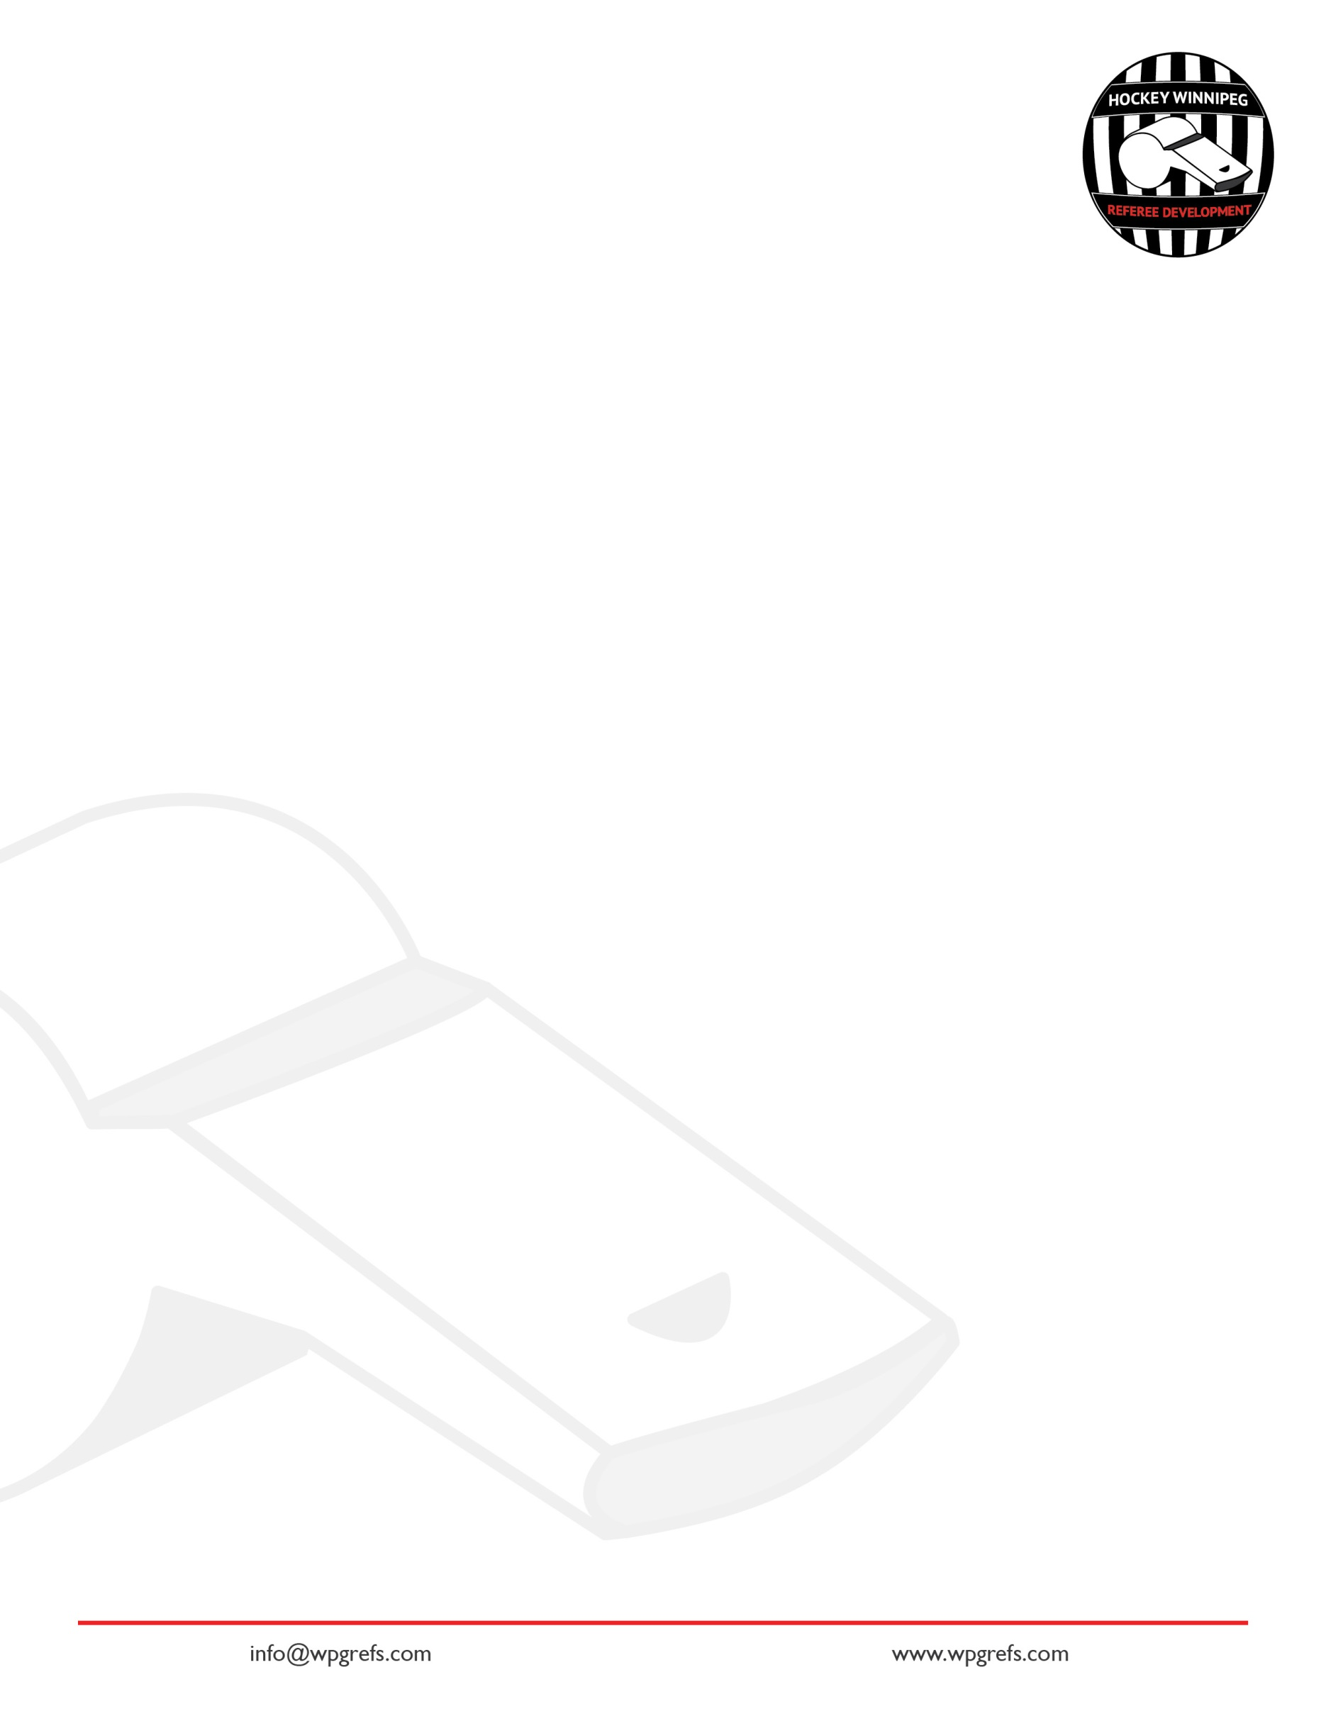
Hockey Winnipeg Referee Development Introduction to Two-Official System

Positioning
While the play is in progress, which phrase best describes the two officials’ position to each other?
1

- The officials are directly across the ice from each other.
- The officials stay in their own endzones and never leave.
- The officials are diagonal from each other.

What two places on the ice does an official have a specific system for positioning?
2

________________________________________________________________________________________________________________________________________________________________________________________________________________________

Working the line Activity
3

- Put this booklet on the floor and pretend it is the blue line. The attacking zone is on that side of the blue line
- As the front official, explain where your feet are relative to the blue line when the puck is in the neutral zone. Why?
__________________________________________________________________________________________________________________________________________
- As the back official, where should your feet be relative to the Blue Line while you watch the play that is in the attacking zone? Why?
__________________________________________________________________________________________________________________________________________
4a

As you watch the play from the blue line, where should your feet be pointed?
A) at the puck.
b) down the blue line.
c) back to the other endzone.

Fill in the Blanks. “When working the blue line imagine a ____________ attached between your belly-button and the ____________ which keeps you square to the play; and makes it easier to get out of the way.”
4b

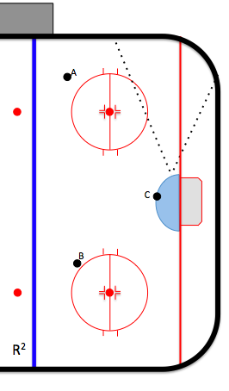
Endzone Positioning Activity
5a

- For puck position A, mark a 1 for where you want to be standing inside the dotted-line cone.
- For puck position B, mark a 2 for where you want to be standing inside the dotted-line cone.
- For puck position C, mark a 3 for where you want to be standing inside the dotted-line cone.

Select the best description for going below the goal line
5b

A) As often as home base, half-piston, at-the-net
B) To get a better view of the play.
C) To get out of the way of the play.
D) Stay as long as you want.
E) return to the piston system as soon as safe to do so.
F) All of the Above.
G) B, C, and E are the best answers.

As the official watching play from the blue line, what cue(s) are you looking for to decide to leave your line to go to the other blue line before the play?
6a

________________________________________________________________________________________________________________________________________________

As the official deep in the zone, what cues are you looking for to skate to your partner’s blue line as the play moves up ice?
6b

________________________________________________________________________________________________________________________________________________

You are the endzone official and puck has left your zone. Your partner has left the blue line to take up a position closer to the other blue line. What do you do?
6c

- Leave endzone positioning and move to the blue line that your partner left to be in position to make an off-side call.
- Stay in endzone positioning and wait for the play to come back to you.
- Stay in endzone positioning and only go up ice if the play establishes in the far endzone.

Procedures
Select the best answer. Procedures are used:
7

- to stop play,
- to manage a stoppage,
- to start play,
- all of the above.

What are examples of procedures for an official? (Hint: Think of what an official does to stop play, manage a stoppage, or start play) ________________________________________________________________________________________________________________________________________________
8

Describe the steps an official dropping the puck follows from the whistle to the start of preparing a face-off.
9a

________________________________________________________________________________________________________________________________________________

Describe the steps the official dropping the puck uses from starting a face-off (while the other official does line change) to dropping the puck.
9b

________________________________________________________________________________________________________________________________________________

At a stoppage, describe the steps for the official not dropping the puck from the point the whistle stops play to the point the puck is dropped (including line change).
10

________________________________________________________________________________________________________________________________________________

When an official stops play, what is the first thing she should do after making the necessary signal?
11

- Retrieve the puck
- Go to the next face-off spot
- Head-on-Swivel
- Go to a place where the players are
- Both c) & d)
12a

In the two-official system, who calls penalties?
- Only the senior official.
- Only the less senior official (to get practice).
- The official in the endzone.
- Both officials call what they see.
12b

Describe the steps for calling a penalty.
________________________________________________________________________________________________________________________________________________

The Very Basics of Game Management
Note: HWRD offers another course that will expand these topics…so…please sign up for “Introduction to Game Management” on wpgrefs.com.
13
Define a “hot spot”.
________________________________________________________________________________________________________________________________________________

Define “presence”
14

________________________________________________________________________________________________________________________________________________

What is the #1 job of the official in the two-official system? (hint #1…think about the previous “Hotspot” and “presence” questions…hint #2…it is not “icing and offsides”) ________________________________________________________________________________________________________________________________________________
15

Explain how positioning and procedures help the officials perform their #1 job? ________________________________________________________________________________________________________________________________________________
16

When should back official (at the blue line) skate into the zone at a whistle?
17

A) every end zone whistle,
b) only if it is his line,
c) if it is his partner’s line,
d) never.

The endzone official stops play; players start pushing. What is the responsibility of the endzone official? Blue line official?
18
________________________________________________________________________________________________________________________________________________

The endzone official stops play; the teams separate. What is the responsibility of the endzone official? Blue line official?
19
________________________________________________________________________________________________________________________________________________

Building Trust in the Arena with Positioning & Procedures
Officials who successfully officiate a hockey game will have the ability to gain the trust of the arena, which allows the official to recover from bad calls or things going wrong. Take a look at each of the following skills (Column 1) and explain how doing the skill correctly allows you to do your job (Column 2) & build trust (column 3). In column 4, give an example of what could go wrong if the skill is not done correctly.

Skill | When this skill is done correctly, what happens to the officials’ ability to make a call/respond to the play? | When this skill is done correctly, what happens to create trust in the arena? | Give one example of what bad things happen when this skill is not done right?
Working the line
Position of feet watching play from blue line
Pursuit of Play-Official on the blue line
Pursuit of play-Official in the endzone
Skill | When this skill is done correctly, what happens to the officials’ ability to make a call/respond to the play? | When this skill is done correctly, what happens to create trust in the arena? | Give one example of what bad things happen when this skill is not done right?
Hustling into the net when the play is stopped.
Head-on-a swivel
Face-Off Procedure for Official dropping the puck
Face-Off Procedure for Official not dropping the puck

