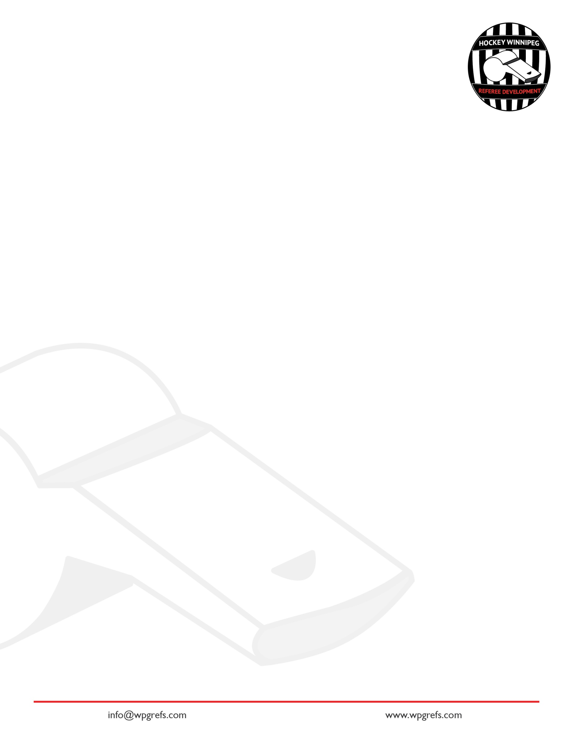
Hockey Winnipeg Referee Development Introduction to Refereeing Course

Positioning
How is positioning in the two-official system same/different to positioning of the referee in the three-official system? ________________________________________________________________________________________________________________________________________________________________________________________________________________________
1

What places on the ice does a referee have a specific system for positioning? How is this different from the two-official system or lining?
2

________________________________________________________________________________________________________________________________________________________________________________________________________________________
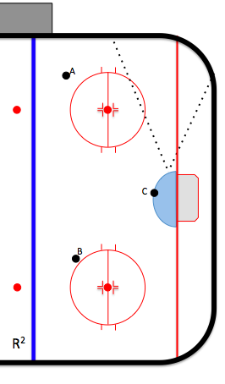
Endzone Positioning Activity
3a

- For puck position A, mark a 1 for where you want to be standing inside the dotted-line cone.
- For puck position B, mark a 2 for where you want to be standing inside the dotted-line cone.
- For puck position C, mark a 3 for where you want to be standing inside the dotted-line cone.
3b

Select the best description for going below the goalline
A) As often as homebase, half-piston, at-the-net
B) To get a better view of the play.
C) To get out of the way of the play.
D) Stay as long as you want.
E) return to the piston system as soon as safe to do so.
F) All of the Above.
G) B, C, and E are the best answers.

The referee is following the play up the ice, how far behind the play does the referee want to be?
4a

- 1-2 Lines
- 2 zones
- Neither. Be 1 line in front of the play.
- Whatever the referee wants.

The referee is skating through the neutral zone approaching the endzone. What two options does she have for where she can stop as she gets to the endzone?
4b

________________________________________________________________________________________________________________________________________________

The puck is on the far side of the ice as the referee follows the play. Where should the referee skate? ________________________________________________________________________________________________________________________________________________
4c

The puck is on the referee’s side of the ice as the referee follows the play. Where should the referee skate?
4d

________________________________________________________________________________________________________________________________________________

Imagine you are sitting in the rafters of the arena watching the referee follow the play back and forth up and down the ice. As the referee pursues the play, which shape best describes the referee’s pattern of skating up and down the ice?
4e
A) A circle with minimal stops and starts,
B) A Line with the referee making a stop & Start at either end of the line,
C) A figure-8 with minimal starts and stops,
D) A cone.

What cues is the referee looking for when choosing to leave the piston system and follow the play up the ice? ________________________________________________________________________________________________________________________________________________________________________________________________________________________
4f

Procedures
Select the best answer. Procedures are used:
5

- to stop play,
- to manage a stoppage,
- to start play,
- all of the above.

What are examples of procedures for a Referee? (Hint: Think of what a referees does to stop play, manage a stoppage, or start play)
6
________________________________________________________________________________________________________________________________________________

Describe the steps for a referee stopping play to the beginning of line change.
7a

________________________________________________________________________________________________________________________________________________

Describe the steps the referee follows from the beginning of line change to the drop of the puck. ________________________________________________________________________________________________________________________________________________
7b

8a

Describe the procedural steps for calling a penalty.
________________________________________________________________________________________________________________________________________________

You have a delayed penalty on 4 Black for cross-checking. The play goes up the ice, as you skate past the linesperson on your side of the ice you say _________________________________.
8b

The player receiving the penalty is standing near to you. How might you modify your penalty call procedure?
8c

- Allow your momentum to carry you away from the player before you come to a complete stop (to avoid a confrontation).
- Nothing. Keep the procedure the same as any other penalty call.
- Announce the penalty with the standard procedure but do not point at the player.
- Grab the player and take him to the penalty box yourself.
- A combination of A, C, and D.
- A Combinaiton of A & C
The Very Basics of Game Management
Define a “hot spot”.
9
________________________________________________________________________________________________________________________________________________

Define “presence”.
10

________________________________________________________________________________________________________________________________________________

Define “Impact Penalty”. ________________________________________________________________________________________________________________________________________________
11

What is the referee’s main role in a hockey game?
12

________________________________________________________________________________________________________________________________________________

Explain how positioning and procedures help the referee perform her #1 job (as described in 12)?
13

________________________________________________________________________________________________________________________________________________

The goalie covers the puck, where should the referee be positioned?
14
A) Homebase, half-piston or at-the-net…your choice,
b) Home base,
c) half-piston,
d) at-the net,
e) if not at-the-net, then hustling to finish at the net as blowing the whistle.

The referee stops play and there is no pushing between the teams. What is the responsibility of the referee?
15

________________________________________________________________________________________________________________________________________________

The referee stops play in the endzone and the two teams start pushing. What is the responsibility of the referee?
16

________________________________________________________________________________________________________________________________________________

Building Trust in the Arena with Positioning & Procedures
Officials who successfully officiate a hockey game will have the ability to gain the trust of the arena, which allows the official to recover from bad calls or things going wrong. Take a look at each of the following skills (Column 1) and explain how doing the skill correctly allows you to do your job (Column 2) & build trust (column 3). In column 4, give an example of what could go wrong if the skill is not done correctly.

Skill | When this skill is done correctly, what happens to the official’s ability to make a call/respond to the play? | When this skill is done correctly, what happens to create trust in the arena? | Give one example of what bad things happen when this skill is not done right?
Using the cone system
Finishing at the net every end-zone stoppage
Pursuit of Play-Figure-8
Pursuit of play-1-2 lines behind the play
Skill | When this skill is done correctly, what happens to the official’s ability to make a call/respond to the play? | When this skill is done correctly, what happens to create trust in the arena? | Give one example of what bad things happen when this skill is not done right?
Penalty Procedure
Line Change Procedure
Head-on-a swivel

