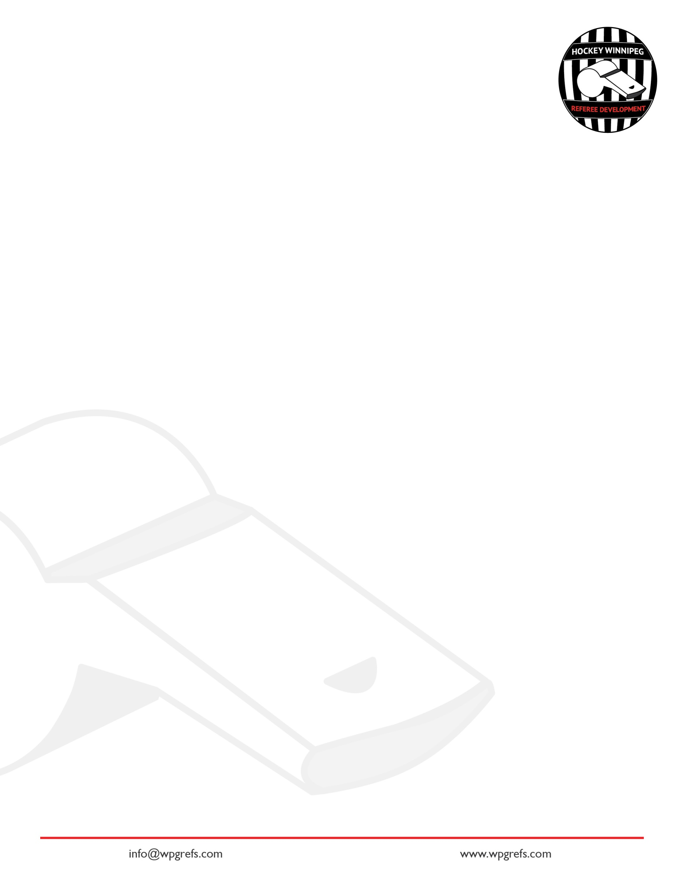
Hockey Canada Rule Changes 2026-2028
The following changes have been applied to the Hockey Canada Rule Book for the current hockey season.

Rule | Change | Impact
Goaltender Safety U13 (Rule 6.18) | Stop play after mask/helmet impact | Increased concussion protection
Penalty Termination (Rule 4.2b) | Delayed & bench minors now considered | Changes penalty-kill strategy
High-Stick Goal Standard (Rule 6.9) | Shoulder vs crossbar height clarified | More consistent goal reviews
Refusing to Start Play (Rule 10.8) | New progression; no 2-min warning | Faster enforcement, fewer delays
Net Dislodged — No Change (Rule 6.1g) | U18 AAA only | Prevents tactical net dislodging
Signal changes | Changes to icing and slew foot/tripping/clipping. | Minor changes to the signals.

Here is a summary video of the rule changes.

The Ontario Minor Hockey Association provided this summary of rule changes.

Rule 6.18 – Goaltender Safety
U13 and Below Only
When a puck strikes a goaltender’s mask or helmet, Officials must stop play as soon as it is safe to do so, while still allowing for a direct deflection into the goal before blowing the whistle. This new rule reinforces concussion awareness and player safety.

Rule 4.2 b) - Minor Penalties
Officials must now consider delayed minor and bench minor penalties when determining whether a penalty terminates after a goal. THIS IS A CONFUSION CHANGE. WATCH THIS video explaining this rule change.

Rule 6.9 - High-Sticking the Puck
The rule itself hasn't changed, however, the standards for judging goals have been clarified:
- Shoulder height determines illegal contact during the play
- Crossbar height determines whether a goal is legal

Rule 10.8 - Refusing to Start Play
The procedure for refusing to start play has also changed. The previous two-minute warning has been removed. Officials now follow a clear progression: A bench minor, or a penalty shot in the final two minutes or anytime in overtime. Teams would then have an opportunity to comply. If they don't, a game misconduct is issued to the head coach and the game is forfeited.

Rule 6.1 g) - Change of Players
U18 AAA Only
When the net has been accidentally dislodged by any defending player, including the goaltender, this will result in a no change situation.

Officials Signals
Several officiating terms and signals have been added or updated this season:
- For all levels of hockey, when a linesperson blows a whistle for icing, they will put their arm up to signal it.
- The signal for slewfooting has also changed. Instead of a forward to backward motion, officials will now signal from backwards to forwards. The tripping and clipping signal, though remain unchanged

Hockey Winnipeg Special Rule (SR) Changes, Additions or Amendments for 2026-2027

Hockey Winnipeg Special Rule Changes
The rule change for 2026-2027 | Note regarding the change
SR5-B: duration of overtime period shall be 5 minutes stop time. If the game remains tied after the 5-minute overtime period, each team shall be awarded 1 point in the standings and recorded as a tie. This is for AA and AAA. | This is clarification regarding the length of period for the new FU15 AAA league.
SR-23: Deleted the rule related to puck striking the goaltender’s head in ‘A’ hockey. | HC add Rule 6.18, which is slightly different from HW’s SR-23 while still addressing goalie safety.  The difference: HW’s rule applied to all ‘A’ hockey whereas HC’s new rule applies to all hockey U13 and below.
SR-23 for U15AAA and U17AAA Co-Ed leagues: The attacking team will choose the side of the face-off following an icing. | Previously, the officials would select the side of the ice on which the face-off takes place.

Please consult your Hockey Winnipeg rule book for full details.

